UXP-HTML5-L1-0001: HTML5 Login Registration Form

Level: L1

Technologies: HTML5, CSS3, Bootstrap**.**

Case Study: To Create Login Form.

**Tips to start**

**Case Study – HTML5 Login Form**

Visual:

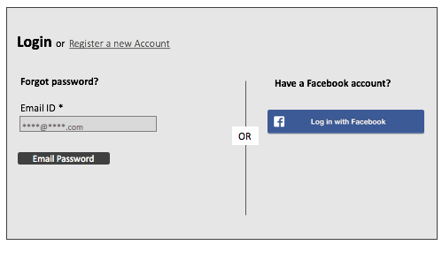

**Getting Started:**

Bootstrap your HTML page, create a HTML5 page with CSS3 and login form.

**Dependencies:**

Develop html page using bootstrap framework create a login form. Refer the links below.

Bootstrap: <http://getbootstrap.com/>

**Additional notes:**

* Create a table in HTML5.
* Create a simple login form with the fields as shown in the Picture above.
* Use placeholders for the input fields.
* <table><tr><td> should not be used.
* Page should be responsive.